A COMPREHENSIVE REPORT ON

**PASSWORD BASED LOCK SYSTEM**

AS PART OF PROJECT FOR THE COURSE OF

EMBEDDED SYSTEMS (ECL 309)

SUBMITTED BY

YASH SACHIN PAWAR BT16ECE020

ADITYA DHOKE BT16ECE008

YASHIKA BAJAJ BT16ECE009

UNDER GUIDANCE OF PROFESSOR VISHAL SATPUTE

Introduction:

In this project we have successfully created a digital lock which checks the password entered by user.

In this rapidly progressing world it is quite advantageous to digitize even tradition locks as keys are replaced by passwords.

These passwords range from a 4-digit number combination to more advanced types such as fingerprint sensor and retinal scanners.

For this project we have used 4-digit number combination.

It has various advantages over traditional locks. Passwords cannot be stolen as simply as keys. Also we could trust someone with our password in time of emergencies. Also digital locks cannot be picked.

If given some additional features, if someone opens it by force, the lock would smartly raise alarm.

Requirements:

* 8051 microcontroller
* 4x4 matrix keypad
* LCD module
* LEDs for status indication
* Assembler such as keil
* Programmer for 8051
* General electronic components
  + Such as wires, resistors, capacitors, BJT etc

Circuit diagram:

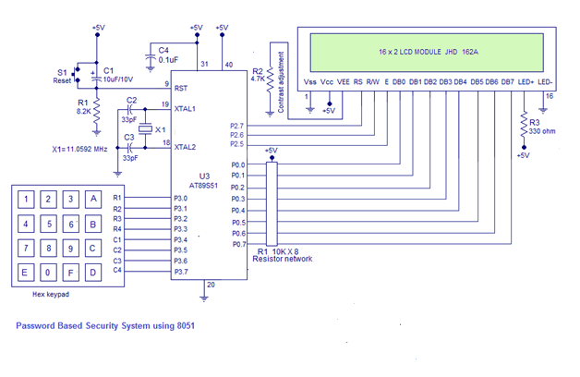

Block diagrams:

uC 8051

PORT

LCD Module

4x4 Matrix

Keypad

PORT

PORT

Working:

Objective of the **Digital Door Lock** project is to allow access to people who input the 4 digit password correctly and to not allow access to people who input password wrongly. The password is stored inside the 8051 program (program memory). we use password **1234** and is stored in program memory location.

When we turn power supplies ON, the system will turn ON with a messaged on LCD screen “PASSWORD”.

The user has to input 4 digits consecutively after this message appears on LCD screen.

Once 4 digits are entered, the system will start checking password (by comparing the input 4 digits with the stored password. The password checking subroutine will compare each entered digit – one by one.

If all the 4 digits are entered correctly (i.e. each entered digit matches with the stored password in order) the system will begin the process of allowing access to the user. A message will be displayed on LCD screen – “SUCCESS”.

If the password entered is wrong, the system will not turn ON the relay and a message “ERROR X” will be displayed on LCD screen.

Hardware Interfaced:

4x4 matrix interfacing:

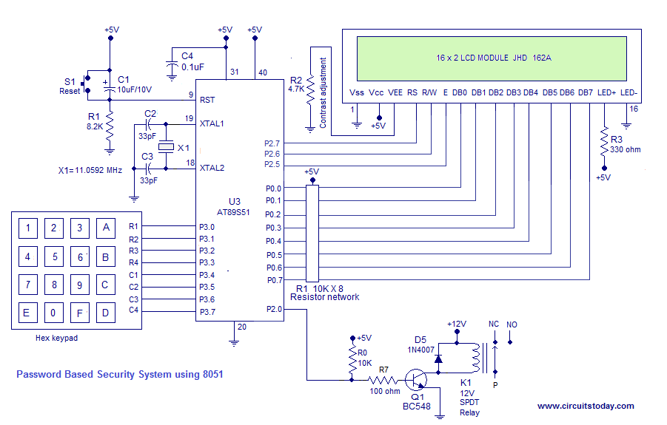

Columns

Rows

To detect a pressed key, the **microcontroller** grounds all rows by providing 0 to the output latch, and then it reads the columns. If the data read from the columns is 1111, no key has been pressed and the process continues until a key press is detected. However, if one of the column bits has a zero, this means that a key press has occurred.

After a key press is detected, the **microcontroller** will go through the process of identifying the key.

Starting with the top row, the **microcontroller** grounds it by providing a low to first row only; then it reads the columns and checks for any zero. If not found program proceeds to nest row. This process continues until the row and column of pressed key are identified.

Knowing both row and column of the pressed key, the key is successfully identified and stored.

16×2 LCD Module to 8051:

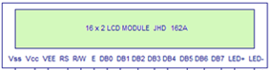

We are using a 16×2 LCD module to display status messages of the project. We have connected this LCD module in 4 bit mode (using 4 data lines). The 4 data lines are connected to Port 0 of 8051.An external pull up resistance is connected using a 10K Resistor Network (with 8 pins) at Port 0 to interface the 8 data lines of LCD. The LCD controlling pins RS, R/W and E are connected to Port 2 pins P2.7, P2.6 and P2.5 respectively.

Future developments: